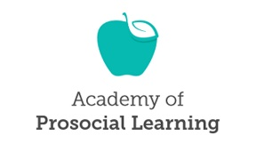
Academy of Prosocial Learning Certified Humane Education Specialist (CHES) Registry Renewal
All fields are required.
Name:
Address:
City:
State:
Zip Code:
Country:
Email:
Phone:
Registry Information:  APL May Share the Following with Individuals Looking for Humane Education Professionals | (check all that apply – if left blank you will remain on the registry but your information will never be shared with those seeking humane educators)  ____ Name ____Email ____Phone
Year of Initial Credential:
Year of Last Renewal (if applicable):
My CHES Credential is Currently: | Active Expired by less than one year Expired by more than one year  If credential expired by over a year, name of humane education course taken for renewal purposes: ______________________________________________________________________  Date of course completion:_________________________________________________________
Amount of Renewal Fee Enclosed: | (Active Credential) $75.00 (Expired Credential) $125.00
Form of Payment: Check # ______
___ VISA ___ MC ___ Discover ___ AMEX #: _____________________________Exp. date: _____
Card Verification Value (CVV – three digit code) ___________
Name on card (please print): ______________________________________
Make checks payable to Academy of Prosocial Learning email or mail this form along with payment to: Academy of Prosocial Learning (c/o Stephanie Itle-Clark), 432 S. Juliana Street, Bedford, PA 15522
Email: info@prosocialacademy.org
Questions? Email us at info@prosocialacademy.org or call 860-262-1807.

Office Use Only:
Account Code:
Rcvd:

